Chapter 18, Solution 45.

We may convert the voltage source to a current source as shown below.

1 H
v_{s}/2 2Ω 2Ω

Combining the two 2-Ω resistors gives 1 Ω. The circuit now becomes that shown below.
I

1 H
v_{s}/2 1Ω

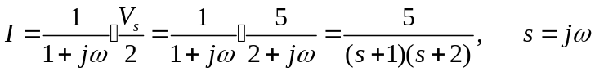
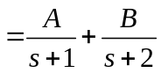
where 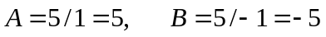
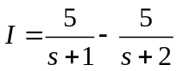
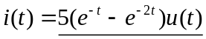A

